TOPIC: JOINS AND SET OPERATIONS

PART 1: CROSS JOIN

STEP 1: CREATE TABLES
CREATE TABLE class (
id INT,
name VARCHAR(30)
);

CREATE TABLE class_info (
id INT,
address VARCHAR(30)
);
STEP 2: INSERT DATA
INSERT INTO class VALUES
(1,'abhi'),
(2,'adam'),
(4,'alex');

INSERT INTO class_info VALUES
(1,'DELHI'),
(2,'MUMBAI'),
(3,'CHENNAI');
QUESTION 1 - CROSS JOIN
SCENARIO:
School administration wants every student to be paired
with every available city for survey analysis.

QUERY:

SELECT *
FROM class
CROSS JOIN class_info;

OUTPUT:

id name id address
-----------------------
1 abhi 1 DELHI
2 adam 1 DELHI
4 alex 1 DELHI
1 abhi 2 MUMBAI
2 adam 2 MUMBAI
4 alex 2 MUMBAI
1 abhi 3 CHENNAI
2 adam 3 CHENNAI
4 alex 3 CHENNAI
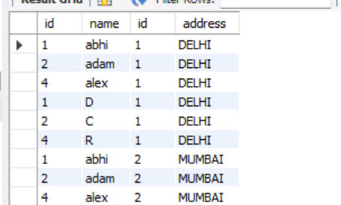
PART 2: INNER JOIN
CREATE TABLE class (
id INT,
name VARCHAR(30)
);

CREATE TABLE class_info (
id INT,
address VARCHAR(30)
);

INSERT INTO class VALUES
(1,'abhi'),
(2,'adam'),
(3,'alex'),
(4,'anu');

INSERT INTO class_info VALUES
(1,'DELHI'),
(2,'MUMBAI'),
(3,'CHENNAI');
QUESTION 2 - INNER JOIN
SCENARIO:
Management wants only students whose address details
are available in both tables.

QUERY:

SELECT *
FROM class
INNER JOIN class_info
ON class.id = class_info.id;

OUTPUT:

id name id address
-----------------------
1 abhi 1 DELHI
2 adam 2 MUMBAI
3 alex 3 CHENNAI
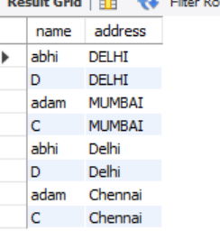

QUESTION 3 - INNER JOIN
SCENARIO:
Find student names and addresses for registered students.
QUERY:
SELECT class.name,
class_info.address
FROM class
INNER JOIN class_info
ON class.id=class_info.id;
OUTPUT:
abhi DELHI
adam MUMBAI
alex CHENNAI
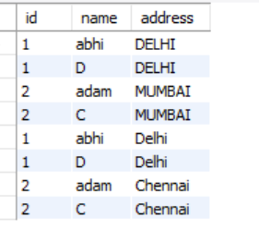
PART 3: NATURAL JOIN
QUESTION 4 - NATURAL JOIN
SCENARIO:
The database administrator wants matching records
automatically joined using common columns.

QUERY:

SELECT *
FROM class
NATURAL JOIN class_info;

OUTPUT:

id name address
------------------
1 abhi DELHI
2 adam MUMBAI
3 alex CHENNAI
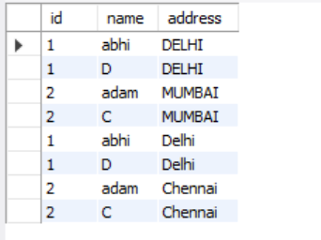
PART 4: LEFT OUTER JOIN
INSERT INTO class VALUES
(5,'ashish');
INSERT INTO class_info VALUES
(7,'NOIDA'),
(8,'PANIPAT');
QUESTION 5 - LEFT JOIN
SCENARIO:
School wants all students even if address information
is not available.
QUERY:
SELECT *
FROM class
LEFT OUTER JOIN class_info
ON class.id=class_info.id;
OUTPUT:
1 abhi 1 DELHI
2 adam 2 MUMBAI
3 alex 3 CHENNAI
4 anu NULL NULL
5 ashish NULL NULL
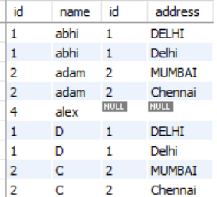
QUESTION 6 - LEFT JOIN
SCENARIO:
Find students who do not have address records.
QUERY:
SELECT *
FROM class
LEFT JOIN class_info
ON class.id=class_info.id
WHERE class_info.id IS NULL;

OUTPUT:

4 anu
5 ashish
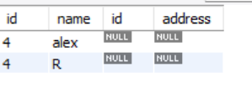
PART 5: RIGHT OUTER JOIN
QUESTION 7 - RIGHT JOIN
SCENARIO:
Administration wants all address records even if
students are missing.
QUERY:
SELECT *
FROM class
RIGHT OUTER JOIN class_info
ON class.id=class_info.id;
OUTPUT:
1 abhi 1 DELHI
2 adam 2 MUMBAI
3 alex 3 CHENNAI
NULL NULL 7 NOIDA
NULL NULL 8 PANIPAT
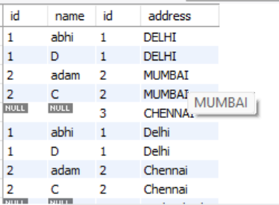
QUESTION 8 - RIGHT JOIN
SCENARIO:
Find address records that do not belong to any student.
QUERY:
SELECT *
FROM class
RIGHT JOIN class_info
ON class.id=class_info.id
WHERE class.id IS NULL;

OUTPUT:

7 NOIDA
8 PANIPAT
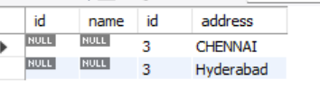
PART 6: FULL OUTER JOIN
QUESTION 9 - FULL OUTER JOIN
SCENARIO:
Management wants all records from both tables,
matched and unmatched.
QUERY:
SELECT *
FROM class
FULL OUTER JOIN class_info
ON class.id=class_info.id;

OUTPUT:

1 abhi 1 DELHI
2 adam 2 MUMBAI
3 alex 3 CHENNAI
4 anu NULL NULL
5 ashish NULL NULL
NULL NULL 7 NOIDA
NULL NULL 8 PANIPAT
